Lê Thanh Phương Nam

ITITWE19025

**Report lab 3**

**Use case 1: The New Student Enrollment Process**

1. **Lists of Primary Actors**

Student: someone who has graduated from high school and passed a national or school examination

OAA: Office of Academic Affair, The office in charge of the English Placement Test and student enrollment

OFP: Office of Finance and Planning, the office in charge of student tuition fees

1. **Goal of Actor**

Goal in Context: The enrollment process for new student including submitting all the required documents, registering compulsory tests and paying the tutition fee.

|  |  |
| --- | --- |
| Actor | Goal |
| Student | Successfully be a new student after enrollment process |
| OAA | Successfully enrolled new students |
| OFP | Successfully collecting tuition fees for the first semester of students |

1. **Candidate use cases**

|  |  |  |
| --- | --- | --- |
| **#UC** | **Actor** | **Action Description** |
| 1 | Student | Preparing the documents required for the enrollment process:  - A high school diploma with a graduate certificate  - A copy of the permanent residence notarization  - A duplicate of the birth certificate  - A copy of your high school profile  - A copy of the ID card, medical insurance certificate, etc.  - Optional English certificate: IELTS, TOEFL, etc.  -A copy of a letter of acceptance |
| 2 | Student | Prepare the admission procedures following the school's timetable, either directly or online. |
| 3 | Student | Submit your document to Thu Duc International University, Room A2.104, or the post office at the following address: Office of Students Services (room O1-105), International University, Quarter 6, Linh Trung Ward, Thu Duc District, HCMC. |
| 4 | OAA | Organize enrollment to receive admission documents for new students, send instruction about the enrollment process |
| 5 | Student | Tuition fees should be paid to the OFP or through school online banking during the first semester. |
| 6 | OFP | Receive the payment fee and return the payment confirmation bill. |
| 7 | Student | Receive the payment confirmation bill, apply for the English Placement Test, and obtain the test schedule from the website. |
| 8 | OFP | Receive the payment fee & Return the payment confirmation bill. |
| 9 | OAA | Get a list of registration forms, set up exam rooms, exam questions, registration numbers, and so on. based on the number of registered students, and send out updates via email and the school's website. |
| 10 | Student | Completing the English Placement Test following the test schedule |
| 11 | OAA | Receives tests, checks, and evaluates them before sending the results to the student via email or posting them on the school's website. |
| 12 | Student | Receive the results |
| 13 | Student | Register for physical education on the website |
| 14 | OAA | Receives physical education registration forms, creates a study schedule and sends it to students via email and edusoft website |
| 15 | Student | Receives the schedule via email or the edusoft website and begins university studies. |

1. **Start point/Endpoint for each use cases**

|  |  |  |  |
| --- | --- | --- | --- |
| Actor | #UC | The Start Point | The End Point |
| Student | UC_1 & UC_15 | Preparing the documents required for the enrollment process | Register for physical education on the website |
| OAA | UC_4 & UC_14 | Organize enrollment to receive admission documents for new students | Receives physical education registration forms, creates a study schedule and sends it to students via email and edusoft website |
| OFP | UC_8 | Receive the payment fee | Return the payment confirmation bill. |

1. **Activity Diagram**

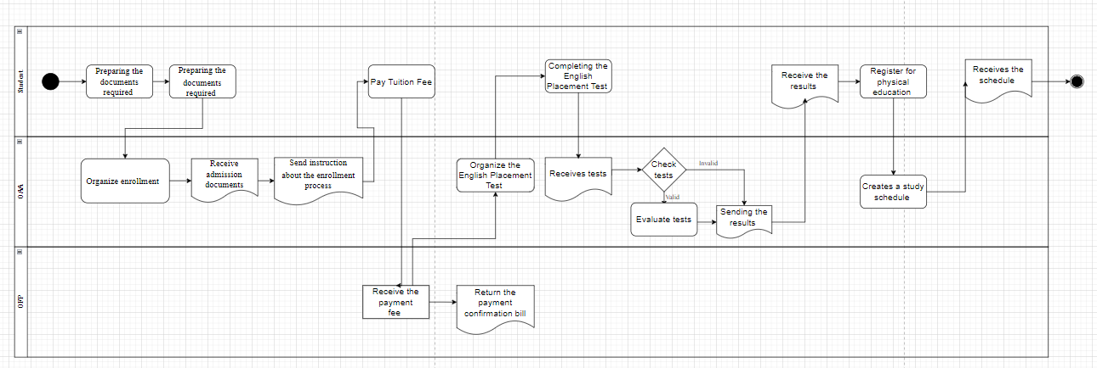

1. **Use Case Diagram**

**Use case 2: The student stand-downs/suspensions/ exclusions/expulsions process**

1. **Lists of Primary Actors**

Advisor: A advisor in charge of following and supporting the students.

OAA The office in charge of creating a list of students who violate the regulation and deciding the appropriate suspension for each student

OFP: the office in charge of tuition fees from students.

1. **Goal of Actor**

Goal in Context: Make rules for students who are on hold, such as suspensions, exclusions, and expulsions, as well as solutions for these students.

|  |  |
| --- | --- |
| Actor | Goal |
| Student | Students 3 times have low results, owe more than the prescribed amount and have not paid tuition fees |
| OAA | Completing the student suspension process |
| Advisor | Complete monitoring, reminders and notifications to OAA |

1. **Candidate use cases**

|  |  |  |
| --- | --- | --- |
| **#UC** | **Actor** | **Action Description** |
| 1 | Student | For the first semesters, students have an overall score of less than 35/100.  Students who owe more than 24 credits from the start of the course for the first time.  Students who have not paid their tuition fees for the first time |
| 2 | OAA | The office sends the first issues alert to students in the list and their Advisor. |
| 3 | Advisor | The advisor will help to solve student solutions at the first time and report the student’s study process to OAA |
| 4 | Student | Students have an overall score of less than 35/100 for the upcoming semesters.  Students who owe more than 24 credits from the start of the course for the second time.  Students who have not paid their tuition fees for the second time |
| 5 | OAA | The office sends the first issue warning to students in the list and their Advisor. |
| 6 | Advisor | The advisor reports the student’s study process to OAA |
| 7 | Student | Students have a third-semester overall score of less than 35/100.  For the third time, students whose total credits owed from the start of the course exceed 24.  Students who have not paid their tuition fees for the third time |
| 8 | Advisor | The advisor reports the student’s study process to OAA |
| 9 | OAA | The Office compiles a list of students who have been suspended. |
| 10 | OAA | The office decides to suspend these students and sends out notices to their home addresses, email addresses, and phone numbers. |

1. **Start point/Endpoint for each use cases**

|  |  |  |  |
| --- | --- | --- | --- |
| Actor | #UC | The Start Point | The End Point |
| Student | UC_1 & UC_4 | Students 1 times have low results, owe more than the prescribed amount and have not paid tuition fees | Students 3 times have low results, owe more than the prescribed amount and have not paid tuition fees |
| OAA | UC_2 & UC_10 | The office sends the first issues alert to students in the list and their Advisor. | The office decides to suspend these students and sends out notices to their home addresses, email addresses, and phone numbers. |
| Advisor | UC_3 & UC_8 | The advisor will help to solve student solutions at the first time and report the student’s study process to OAA | The advisor reports the student’s study process to OAA |

1. **Activity Diagram**

1. **Use Case Diagram**

**Use case 3: The Graduation Application Process**

1. **Lists of Primary Actors**

Student: A student who study in International University and is qualified to graduate

OAA: the office in charge of the graduation process from students

Major Office: the office in charge of the thesis for students.

OFP: the office in charge of checking tuition debt

1. **Goal of Actor**

Goal in Context: The student successfully applies graduation ceremony

|  |  |
| --- | --- |
| Actor | Goal |
| Student | The student has been graduated successfully |
| OAA | Successful Announcement of graduation results and send Successfully an inviting Ceremony letter to Student |
| OFP | Successfully checking tuition debt |
| Major Office | Successfully send results of the student in the list’s thesis defense |

1. **Candidate use cases**

|  |  |  |
| --- | --- | --- |
| **#UC** | **Actor** | **Action Description** |
| 1 | OAA | Make a list of qualified students to graduate  Announce of graduation consideration for students in the list via email, website, edusoft |
| 2 | Major Office | Sends the results of the student in the list’s thesis defense to the OAA:  -Dissertation defense record  -Application for graduation according to the form  - Documents attached as prescribed |
| 3 | Student | Submit their graduation application to the OAA:  Graduation application form  Scientific background:  3 3×4 photos (white background, taken within 6 months, dressed politely).  Photocopy of birth certificate.  Copy of university diploma with notarized transcripts within 6 months.  English certificate according to the regulations of the school.  Dissertation defense file |
| 4 | Student | contact the OFP for information about tuition debt (if any) |
| 5 | OAA | Receive the students’ graduation application documents and check the information |
| 6 | OAA | Organizes graduation examination |
| 7 | OAA | Announcement of graduation results and send an inviting letter to Student |
| 8 | Student | Receive inviting letter and graduation results  Prepare and participate in the Graduation ceremony |

1. **Start point/Endpoint for each use cases**

|  |  |  |  |
| --- | --- | --- | --- |
| Actor | #UC | The Start Point | The End Point |
| Student | UC_3 & UC_8 | Submit their graduation application to the OAA | Participate in the Graduation ceremony |
| OAA | UC_1 & UC_7 | Make a list and announce the qualified students to graduate | Receives physical education registration forms, creates a study schedule and sends it to students via email and edusoft website |
| OFP | UC_4 | checking tuition debt (if any) | |
| Major Office | UC_2 | Sends the results of the student in the list’s thesis defense to the OAA | |

1. **Activity Diagram**

1. **Use Case Diagram**

